**TUTK Mobile app operating Guide**

**1：Software search and installation**

Android market search：SmartViewer

IPhone market search：SmartViewer

Find the following app icon to download and install：

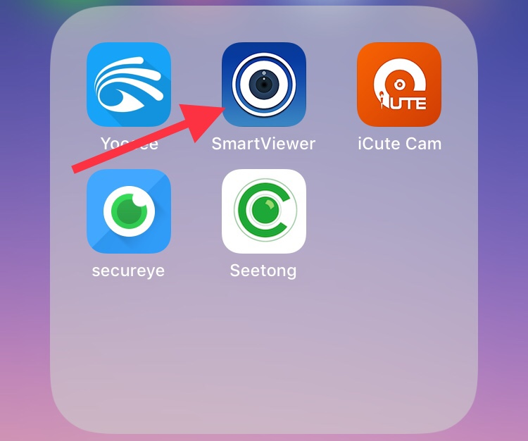

**2：Device connection external network setting**

The device IP address must be able to access the network normally,and notice that the default gateway is consistent with the DNS server and router related settings.

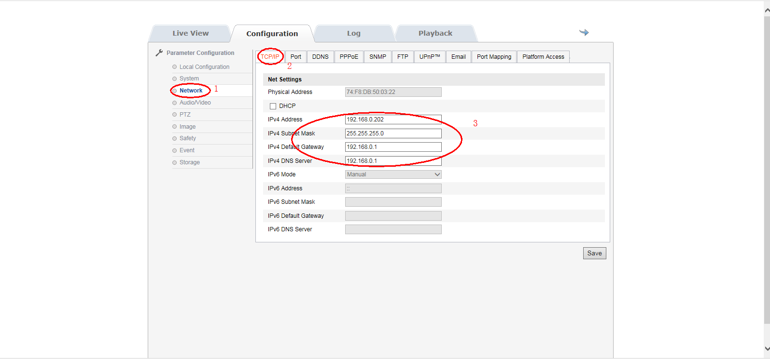

**3：P2P function turned on**

After selecting to open, wait for the device to restart automatically, as shown in the following figure:

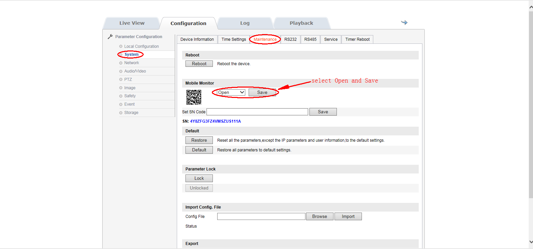

**Note: the device ID needs to contact the relevant agent, the first time you need to set up the ID ,After ID settings completed, the new ID will not take effect until the device is restarted.**

**4：**Open the phone client and add the device ID by scanning the device's QR code, as shown in the following figure:

Follow the operation wizard step by step, fill in the device user name password, note: the default user name and password all are admin.

