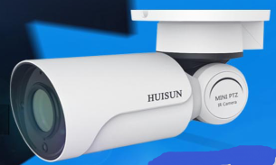
2MP Fixed Lens Integration bullet PTZ Camera
- National invention patent design : The bullet camera with round bracket .(patent No : 2017300368380 )
- National invention patent design : The camera of round bracket . (patent No :2017300368376 )
- National invention patent design : The new gear reversing transmission technology . (patent No : 201710112514X )
- National invention patent design : Bullet PTZ Camera ( Patent No : 2017201860042 )
- National invention patent design : Integrated PTZ Camera structure . (Patent No : 2017201867431 )
- Built in RTC for Timing function .
- 2 MP 1/2.7”SC2135 CMOS Sensor + MSTAR MC313E DSP
- Support with 6mm fixed lens (Optional 4mm,6mm,12mm)
- Support with ONVIF .
- Pan speed : 0.1°~20°/ s ,tilt speed : 0.1°~12°/ s
- Double ICR , WDR ,ROI , BLC
- IP66 ,TVS 4000V Protection .
- App name : VRCAM
Application scenario :
Application for the place which are required more HD Image ,more beautiful ,such as warehouse , area , wharf ,square ,school ,park ,station .
Size dimensions :
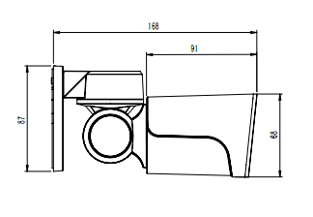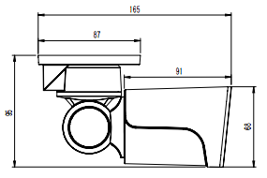

Specs :

Model |  |  | DM-SLB405IJP-C06-(W)
camera | Audio | sensor | 1/3" CMOS
camera | Audio | Image | 1080P(1920X1080)
camera | Audio | shutter | 1/25s ~ 1/100000s
camera | Audio | Iris | F2.0
camera | Audio | Day&Night | ICR
camera | Audio | Illumination | 0.01Lux @(F2.0,AGC ON) ,0 Lux with IR
camera | Video | Video compression | G.711-u law
camera | Image enhance | Image setting | AWB, AGC adjust
camera | Image enhance | Image setting | Exposure Mode  Manual /auto
camera | Image enhance | Image setting | Adjust , Sharpness, Saturation, Brightness & Contrast Adjustable ;white balance ,
camera | Image enhance | 3D Position | not support
camera | Image enhance | DWR | D-WDR
camera | Image enhance | D-Noise | 2D/3D-DNR
camera | Image enhance | Image Orientation | Mirror/Flip
camera | Image enhance | Privacy Zone | support
camera | Image enhance | motion detection | support
camera | Image enhance | OSD | Chinese &English
compression Standard |  | Chip | HI3518E-V200
 |  | Video compression | H.264/ H265
 |  | Frame | 50HZ:25fps(1920x1080) 60HZ:30fps(1920x1080)
 |  | Bit Rate | 32kbps-.3.5Mbps
 |  | rate control mode | VBR/CBR
 |  | image effect | VBR：5 adjustable mode CBR： Can adjustable freely
Cover/Housing |  | Focus | 6mm
 |  | Iris | Fixed Iris
 |  | lens connector | M12 connector
 |  | protection | IP66
 |  | Bracket | wall bracket ,pend bracket
 |  | size | 168mm×68mm×68mm（length ,wide ,high
 |  | Gross | 360g
PTZ |  | Optical zoom | Fixed Focus: 6mm
 |  | IR Distance | 50M
 |  | Pan speed range | 0°~200°
 |  | Tilt speed range | 0°~60°
 |  | Pan speed | 0.1°~20°/ s
 |  | Tilt speed | 0.1°~12°/ s
 |  | Preset | Not support
communication interface |  | network | RJ45
 |  | Power | DC 12V
 |  | TF Card | （max 64GB ）
 |  | Cloud storage | Not support
 |  | Audio | one Audio in ,one audio out ( optional)
 |  | Alarm | not supprot
network |  | Remote control | Phone APP
 |  | Phone client | Support with Windows Mobile、iPhone、iPad、Android
 |  | User | Supports simultaneous monitoring for up to 4 users with multi-stream real time
 |  | network protocol | TCP/IP, UDP, DHCP, NTP, RTSP, PPPoE, DDNS, SMTP, FTP
 |  | ONVIF | Support
 |  | Ethernet | 100Mbps
 |  | Wifi | not support
 |  | PoE | not support
others |  | Power | DC12V
 |  | Work Environment | -30℃~60℃ ,humidity range : 10%~90%

