IP CAMERA
WEB UserManual

Versionv3.0
Release date 2021-03-9

Modify Record
版本 | 日期 | 描述
2.0 | 16th August,2018 | createv2.0
3.0 | 20th March,2019 | createv3.0,WEB use of IPCAMERA before finishing
3.1 | 14th June, 2021 | Converting Chinese Pictures into English Pictures

IP CAMERAWEBUser Manual

Version 3.0

stateme

Thank you very much for purchasing our products, if you have any questions or needs in the use of the process please feel free to contact us.
This manual is based on the current software and hardware, as a result of the update, modification and upgrade, as well as hardware equipment upgrades, may cause manual description of the technical problems exist inaccurate or imperfect place, please understand. If you can not solve the problem in accordance with the use of the manual, please call our technical department to contact the relevant methods of operation. Manual will be updated regularly, if necessary, please go to my company website download, without notice. software Download Address: www.icamra.cn
Warmprompt

Recommended PC base configuration:CPU four core 3.0GHz,4G memory,512M Independent graphics card,2.1 sound card, Audio output,MIC input,WINDOWSXP/7/8/10

目录
1、Product Description 6
1.1 Product Introduction 6
1.2 Features 6
2、Installation & use 7
2.1 Device connection 7
2.2 Control installation 8
3、 Login 10
4、Camera settings 13
4.1 Video capture settings 13
4.2 OSD 14
4.4Privacy mask setting 14
4.3 Video encoding settings 15
4.4 Audio encoding settings 16
4.5 Audio capture settings 17
5、Network 17
5.1basic configuration 17
5.2 P2P Setting 18
5.3 Stream Media 18
5.4 SMTP 19
5.5 GB28181 19
5.6 RTMP 20
5.7 Connection check 20
6、PTZ Setting 21
6.1 PTZ setting 21
7、Alarm Setting 21
7.1Motion Detection Alarm Setting 21
8、Storage Settings 25
8.1 Storage Settings 25
8.2Timed Recording 26
8.3Storage Device Information 27
8.4Storage Device Management 28
9、System Settings 29
9.1 Account Management 29
9.2 Device Language 30
9.3 Timer Setting 31
9.4 Restore Factory 32
9.5Reboot 32
9.6 Regular Maintenance 32
9.7 Firmware upgrade 33
10、Version Information 34
11、FAQ 35
11.1 Cannot access device through browser 35
11.2 Yuntai cannot control 35
11.3 Normal data cannot pass through the switch 35
11.4 Error accessing the device through the browser after upgrading 35
11.5 After the click, the intercom can't hear the sound. 35

1、Product Description

1.1 Product Introduction
IPCAMERA is an embedded system, which is a 38*38 HD dedicated network module for compressing and processing audio and video data. It consists of audio and video compression encoder, input and output channels, network interface, audio and video interface, RS485 serial interface and protocol interface. The software interface and the like also provide video processing functions, mainly complete image data collection, H.264 image data compression, Internet transmission data and audio data processing, and can transmit real-time images and sounds simultaneously through the network.
IPCAMERA uses a faster computing digital processor to quickly compress larger and clearer images. It uses an advanced operating system and audio and video compression algorithms to make sound and image transmission smoother and clearer and more detailed. The embedded server is completely out of the PC platform, the system scheduling efficiency is high, the code is solidified in FLASH, and the system runs stably and reliably. Support remote image access via Internet Explorer. Supports two-way voice intercom, supports dynamic IP address, and facilitates network transmission of images and sounds.

1.2 Features
◆H.264/H.265 video compression standard, AAC/G.711 audio compression standard
◆Embedded Web Server, fully supports Internet Explore monitoring, configuration, and upgrade
◆Two-way audio real-time transmission on the Internet, video frame rate is automatically adjusted according to bandwidth
◆Support variable rate, while setting the video image quality, can also limit the compressed stream of video images
◆Support level 2 domain name, easy to implement dynamic IP address (ADSL dial-up)
◆Video code rate 50mbps-8Mbps (50mbps-6Mbps) continuously adjustable, frame rate 1-30 (1-25) continuously adjustable
◆Support capture, local video
◆Support motion detection (settable area and sensitivity)
◆Alarm pre-recording function
◆10/100M Ethernet interface support
◆Support IO interface to connect other peripherals
◆RS485 interface, network transparent channel connection, the client can be controlled by the transparent channel of the device
◆Support multiple users to access simultaneously
◆Alarm signal input and output
◆Support for scheduled maintenance
◆Support for networked storage and capture
◆Support WEB configuration
◆Support OSD
◆Support client remote monitoring software
◆Support PTZ
◆Support mobile phone monitoring
◆Support for crossing services

2、Installation & use

2.1 Device connection
The connection diagram of the entire system framework of IPCAMERA is shown in Figure 1.1. Connect the various parts and connect the PC and IPCAMERA device directly through the switch or router. Configure the following basic network parameters: a. The IP address of the device at the factory is 192.168.0.123. The code is 255.255.255.0 (to determine the IP address of the camera, you can use the matching AjDevTools search tool or install the LMS client in Device Management > Add Device) to set the PC to access the 0 network segment. b. The PC and camera have the same subnet mask settings. In WINDOWS, press: Start-Run-cmd, enter ping 192.168.0.123 and press Enter to determine if the network is open. An example of operation is shown in Figure 1.3, Figure 1.4, and Figure 1.5. When the network is unreachable, please recheck the network connection and settings to ensure network connectivity.
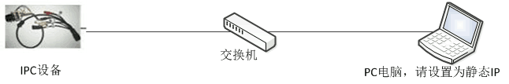
Figure1.1 Network connection diagram
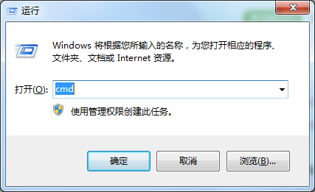
Figure1.2 Enter "cmd" command in "Start" - "Run"
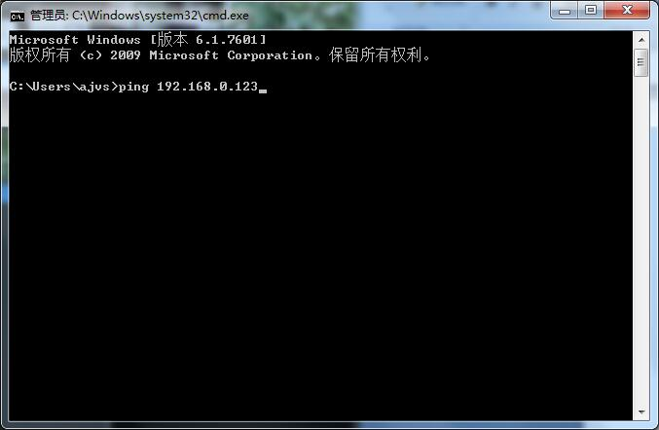
Figure1.3 Enter cmd and press Enter to enter the ping command
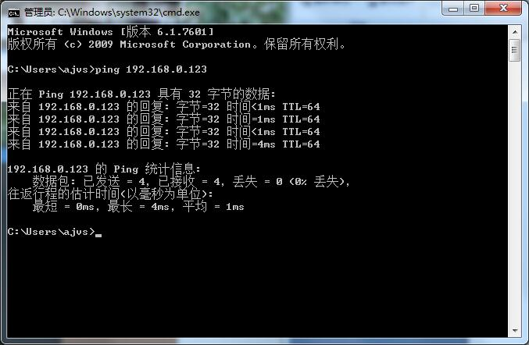
Figure1.4 Enter the ping command and press Enter to connect to the network
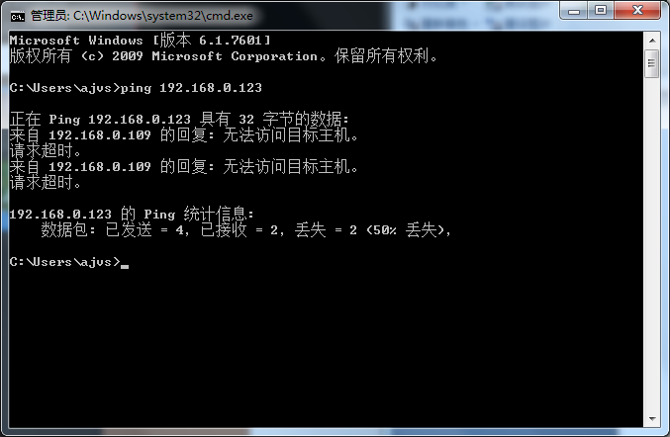
Figure1.5 Enter the ping command and press Enter. The network is unreachable

2.2 Control installation
After all the parts of the device are connected and the network settings are completed, enter the IP address of IPCAMERA in the address bar of the PC browser, and press Enter to enter the login interface of the device web. If you are accessing the device for the first time through a browser, you will be prompted to install the control. If the same version of the control is already installed on the PC, go directly to the login screen shown in Figure 2.4. The control installation steps are as follows:
a. After entering the device IP address, the interface shown in the figure below may appear. This is because the control is not authenticated. Click the "Allow" button.
Figure2.1 Security warning, click "Allow" to enter the next step
B.Then the message shown below appears, click "OK" again.
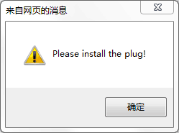
Figure2.2 Prompt to install the control
C.After clicking "OK", different interfaces may appear depending on the browser version. Some browsers will directly pop up the software installation interface, as shown in Figure 2.3. If the browser does not pop up the interface, look at the bottom of the browser, a line of text "Please install the control!", click on the line of text, you can also link to the control installation interface.
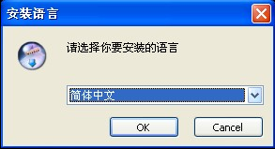
Figure2.3 Control installation interface
- According to the prompts to correctly install the control, it is necessary to note that during the installation process, all open browsers on the computer must be closed, otherwise the control may not be installed successfully.
- After the installation is successful, re-open the browser, enter the device IP address in the browser address bar, and press Enter to go to the device login interface, as shown in the following figure.
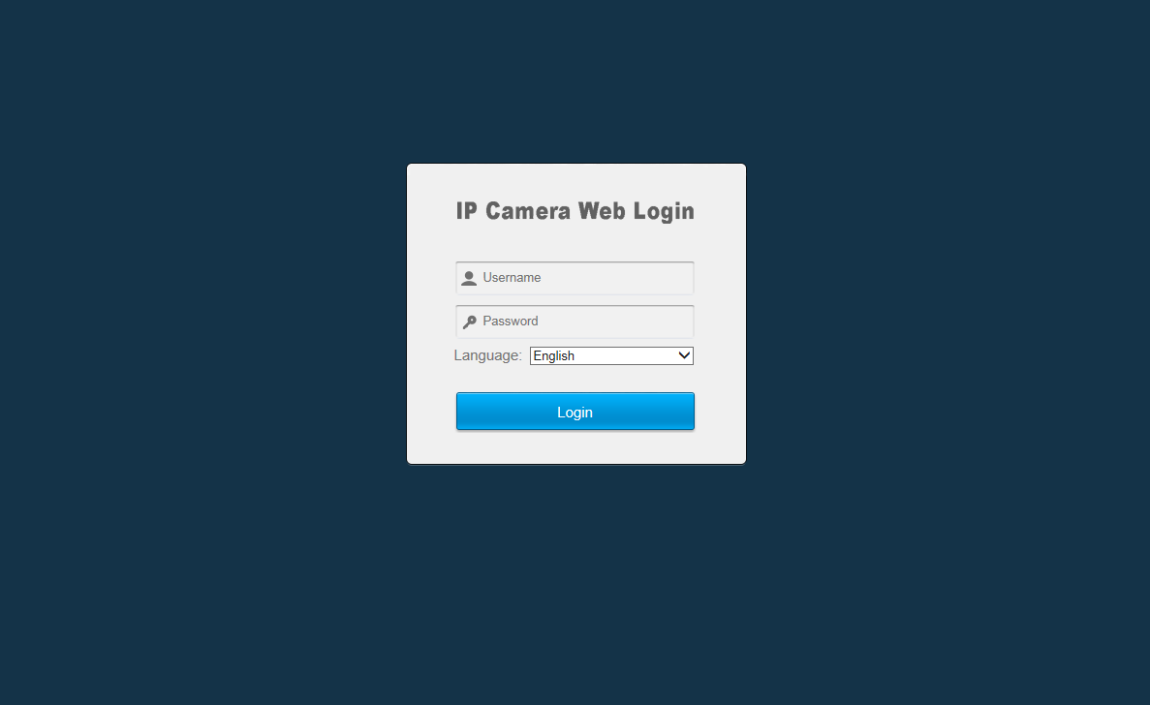
Figure2.4 After the control is properly installed, enter the device login interface.
Be careful：1、During the control installation process, due to different versions of the IE kernel browser, different interfaces may appear. Users need to follow the prompts to install. Some anti-virus software will prompt that the security problem is caused by the security authentication of the control, but it will not cause any security risks. This kind of prompt can be ignored, click OK to complete the installation process.
2、Before installing the control, you need to close all currently open browser interfaces, otherwise the installation may not be successful. If multiple installations are unsuccessful, it is recommended to clear the browser's cache before reinstalling.
After entering the login page, enter the user name and password (the default user account and password for IPC are admin and 123456 respectively). After inputting, click the "Login" button to log in normally. The login interface also supports the installation, downloading, and selection of interface languages. Users can set the interface language according to their needs. IPC now supports six languages: Simplified/Traditional Chinese, English, Russian, Turkish, Korean, and Czech.

3、 Login
Enter the correct username and password in Figure 2.4 and log in to Figure 3.1 as follows:
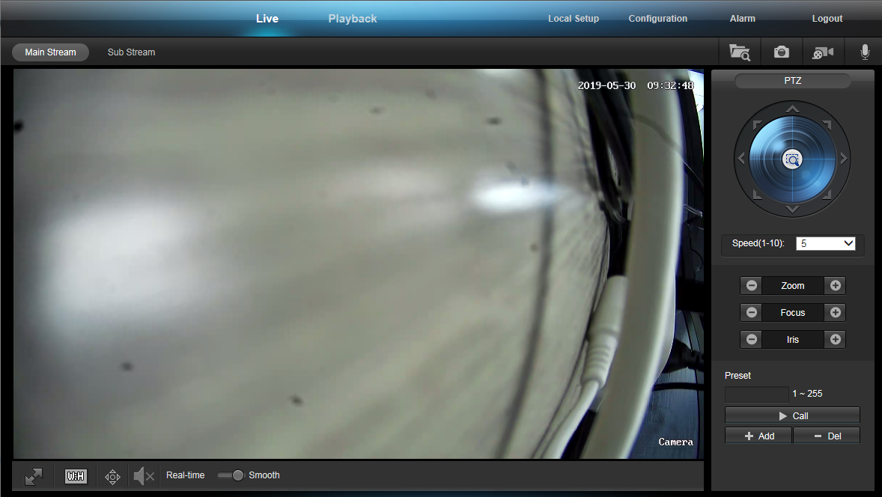
Figure3.1
This interface is the interface after the web login, it is composed of three parts:
A：Upper function area: This part has six function buttons, live broadcast, playback, local settings, configuration, alarm, and exit;
The function of playback is to watch, download, delete the previously stored video, and open it will enter Figure 3.2. Here we perform the operations of the functions provided by the playback.
The configured functions are network settings, media settings, pan/tilt settings, storage settings, alarm settings, and system settings. When opened, it will enter Figure 3.3.
The alarm is used to display alarm information such as motion detection and humanoid detection.
Here we can configure the parameters of the device. Detailed parameter settings are described in the next section.
The function of exiting is to exit the web side of the device and exit to enter Figure 2.4.
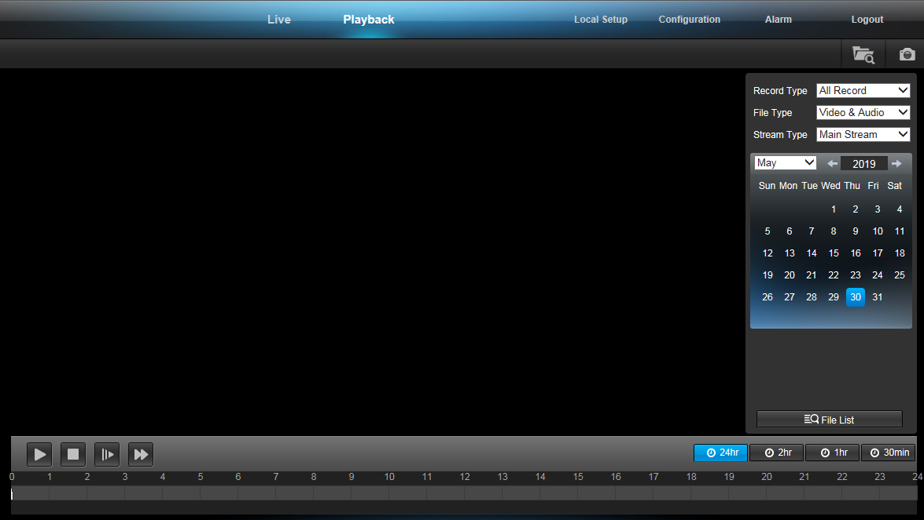
Figure3.2
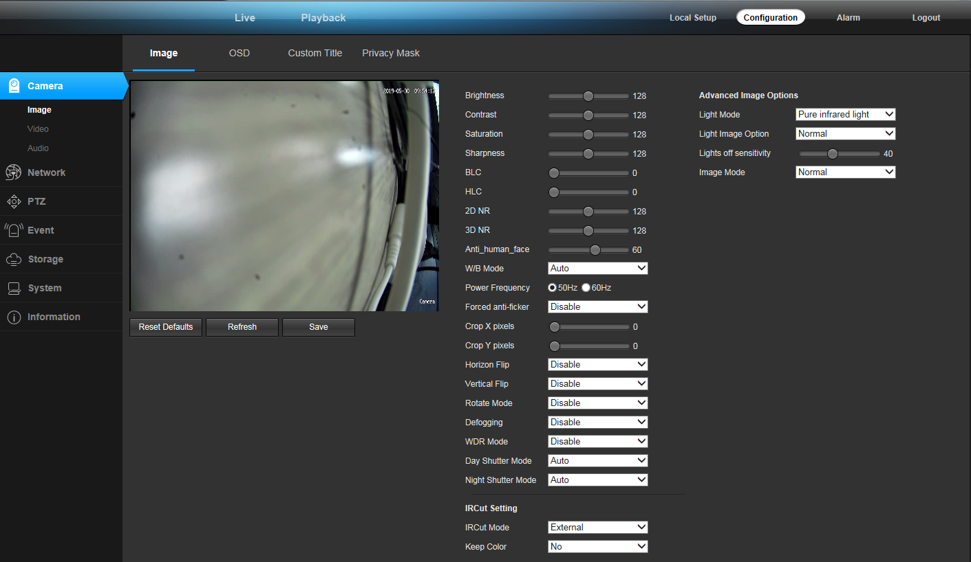
Figure3.3
B：On the right side of the PTZ control panel, the functions of this part are: (from left to right, top to bottom)
Stream setting：Set the video playback window to play the video main stream or the video substream.
C：右边的监控视频播放窗口：播放实时流，可以根据需要选择播放视频主码流或视频子码流。播放时双击播放窗口可以实现视频的全屏显示
Storage path：Configure the save path of the captured pictures and videos. After setting, when the snapshot picture or video is generated, the system will automatically generate a folder of the current date to save the picture or video file in the set directory.It is worth noting that the set storage path will not be saved after exiting.
Capture：Click the button to capture the current video screen.
Video：You can record by clicking the button. A red dot appears in the upper right corner of the right monitor video playback window to indicate that the device is recording. The storage file save path defaults to the folder created under the C drive with the current date as the file name, and the storage path can be modified by itself. It should be noted that when the remaining space of the disk where the set video file save path is located is less than 2G, recording will not be possible.
Intercom：If the device has audio capability and audio is turned on, clicking this button will allow an intercom between the PC and the front-end device. The button flashes to indicate that the intercom is currently in progress.
PTZ direction control：After connecting with the pan/tilt, it can control the pan/tilt up, down, left, right, top left, top right, bottom left, bottom right and automatic 9 directions. Click on a direction control button and the pan/tilt will continue to rotate. The direction of rotation has upper and lower limits).
amplification：Control the focal length of the camera lens and click this button to zoom in on the lens.
Zoom out：Control the focal length of the camera lens and click this button to zoom out the lens focal length.
Far focus：Click this button to increase the focus.
Near focus：Click this button to shorten the focus.
Aperture open：Click this button to enlarge the aperture. The larger the aperture, the more the amount of light entering, the brighter the picture.
Aperture off：Click this button to reduce the aperture, the smaller the aperture, the darker the picture.
Speed adjustment：The speed of the left and right rotation of the gimbal can be adjusted between 0-10, the speed is 0, the rotation is slow, and the speed is 10, the rotation is the fastest. It is worth noting that after the speed value is modified, the modified value will not be saved after switching the interface or exiting the login again.

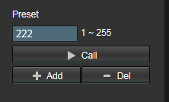
Figure3.4 Patrol/line sweep function settings
Preset:Before enabling the prefabricated point function, you need to set the preset point. After setting multiple preset points, pull down the patrol option shown in Figure 2.8 and click the right execution button to realize multiple settings of the dome. Sweep back and forth between preset points.
Stop patrol：Pull down to select the Stop Tour option shown in Figure 2.8 and click the Go button on the right to stop the tour scan.
Increase preset point：You can increase the preset point between 1 and 255. Turn the lens to a position, input the preset point number, and click the “+” sign on the right side of Figure 2.9. The preset point is added successfully. After the preset point between 1 and 64 is increased, it can be queried in the Delete Preset Point and Call Preset Point drop-down list. Preset points between 65 and 255 cannot be deleted, but can be called manually. After setting a preset point, rotate the lens to continue the setting of the next preset point.
Delete preset point：Select the preset point to be deleted from the pull list in Figure 2.9 and click the “-” on the right. The selected preset point is cleared from the list, and multiple preset points can be deleted continuously.
Call preset point：From the drop-down list in Figure 2.9, select the preset point number to be called, click the call button on the right, and the lens will rotate to the position where the preset point is set. If the selected preset point is the current position, then click to go without lens. Turn the action.

4、Camera settings

4.1 Video capture settings
Video capture settings are shown in Figure4.1
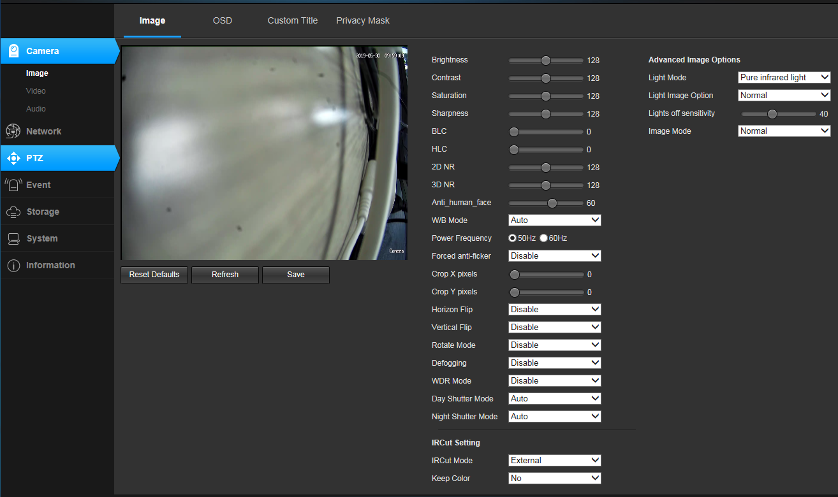
Figure4.1
The brightness, saturation, sharpness, contrast, and backlight values ​​need to be entered manually. The setting range is 0-255. The larger the brightness value, the brighter the field of view; the larger the saturation value, the more obvious the color discrimination; the larger the sharpness value, the more saturated the image; the larger the contrast, the more obvious the contrast effect of the image. The settings of brightness, saturation, sharpness, contrast, and backlight value should be adjusted according to the actual environment of the site, not the larger the value, the better. The device supports the video flip function, enabling horizontal flipping, the video screen will be rotated 180 degrees horizontally, vertical flipping enabled, and the video screen will be rotated 180 degrees vertically. Adjust the video format by adjusting 50Hz/60Hz. After the defogging function is turned on, there is a similar effect of increasing the contrast to achieve the defogging function. WDR is a wide dynamic function, and WDR is the ratio of the brightest signal to the darkest signal that the device can distinguish. The set orientation is 0-255. A set of default parameter settings is provided in the video capture parameter settings. Click the “Default Parameters” button at the bottom right of the interface, and all the parameters in the interface will be restored to the default values. If you think that the default parameters are not optimal, you can set the parameters according to your needs.
The video capture settings are divided into two areas, "IRCUT Settings" and "Video Capture Parameter Settings".
IRCUT has four working modes: active mode, day and night mode, passive mode, and manual mode.
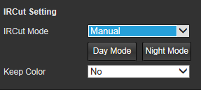
Figure4.2

The active mode is controlled by the module to control the light board, and the color and black and white pictures are automatically switched by the light intensity; the day and night mode is set by the night start time and the night end time, and when enabled, the black and white picture is always maintained during the set time period. The set time is determined according to the device time, so the device is also based on the device time when switching the IRCUT; the passive mode is switched by the level control signal control module IRCUT sent by the light board; the manual mode can be manually switched Day and night mode; reverse passive mode is the same as passive mode, except that the high and low levels are exchanged, that is, when the video picture is colored in passive mode.
When you want the device to be in full color mode, you can turn on the "Keep Color" feature. "Keep color" select "Yes", regardless of the working mode set, regardless of the external conditions, the device is always in color mode, IRCUT will not switch. “Sensitivity” refers to the agility of the device's sensitivities and only works in “active mode”.

4.2 OSD
The time and title settings are a setting for setting the time and title display on the video interface. The user can define the title content, set the time and title display position, select the overlay information, and set the display format of the time.
When the OSD display is set to Enabled, time and title information will be displayed on the video screen; no information will be displayed when disabled.
Additional information is used to set whether to display resolution and bit rate. There are four options: no overlay, overlay resolution, overlay rate, overlay resolution, and bitrate. The user can set whether to superimpose the display resolution or code rate on the video screen according to his own needs.
The style display default transparent background black box white, users can choose one of 4 modes.
The time display has 8 formats to choosefrom.
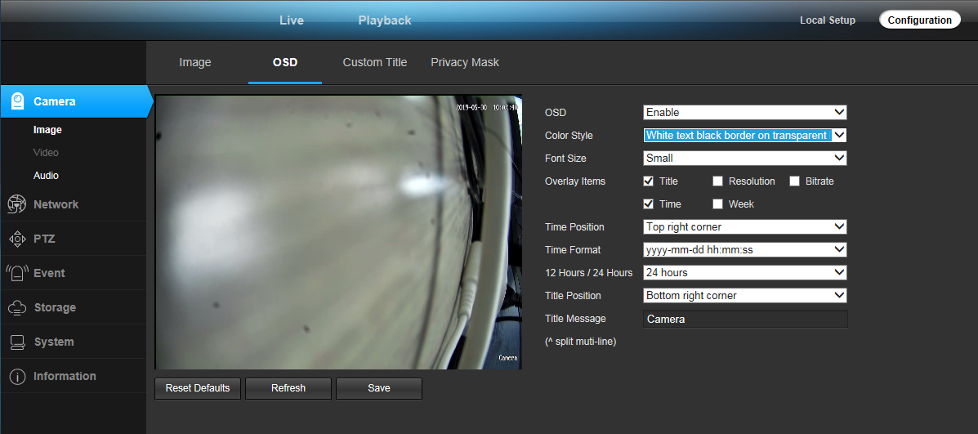
Figure4.3

4.4Privacy mask setting
When some parts of the video picture are desired to be hidden, these areas can be set as privacy occlusion areas. When configuring the privacy mask area, you can use the mouse frame in the image area and click OK to complete the setup. The place that is set as the privacy zone is displayed in black or white, whether it is in the live stream or in the video file.
If the set privacy mask needs to be modified or removed, you can click the “Clear” button and click “Clear”, the privacy mask area will becleared.

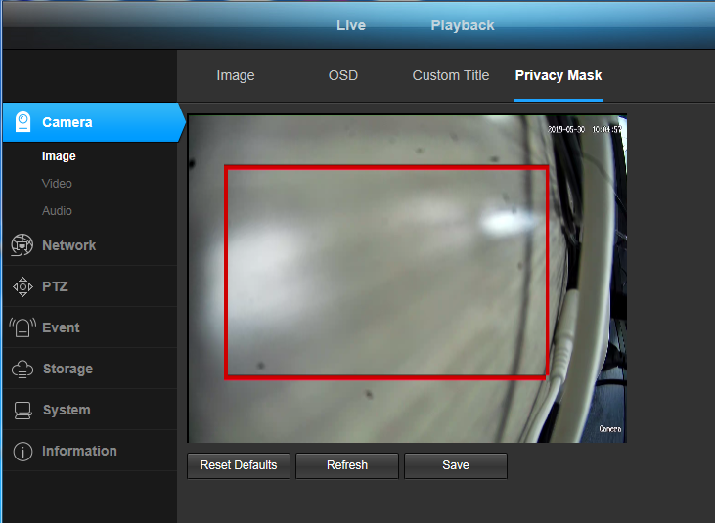Figure4.5

4.3 Video encoding settings
The video encoding settings area contains two aspects: video encoding parameter settings (Figure 4.4) and advanced encoding parameter settings (Figure 4.5).
The video has two streams, which are the main stream and the sub-stream respectively, and the encoding format used is H.265.
IPCAMERA main stream has three resolutions, 1080P, 960P, 720P and other resolutions (depending on the specific model), users can set according to their own needs. In order to achieve a trade-off between network bandwidth and image quality, a bit rate control method is adopted. When the amount of image information suddenly increases and the bandwidth is limited, dynamic rate (VBR) transmission can be adopted to ensure image quality. If fixed rate (CBR) transmission is used, images may appear mosaic, jitter, and the like. CVBR is a priority fixed rate transmission and is compatible with variable rate control. The bit rate control has no obvious influence on the image quality when the network bandwidth is sufficient. The specific selection of the control mode should be determined according to the client network.
A frame is a key identification frame for video coding. If the frame interval is too large when the network bandwidth is too small, the acquired image quality may be poor or even a real image may not be obtained. When the network conditions are good, there is no strict requirement for the frame interval setting. The specific settings can be gradually adjusted to the optimal value by the preview setting effect.
The bit rate Kbps refers to the network transmission speed, that is, how many thousands of bits of information are transmitted per second, compatible with multiple resolutions, because the resolution of the primary stream is multiples of the substream, and the amount of information transmitted per unit time. Large, so a relatively large transfer rate is required. The main code stream generally requires not less than 500 kbps, and the sub-stream requirement is not less than 50 kbps. The transmission rate is too small, and the image will appear sticky, slow update, and poor interaction.
The larger the frame rate, the smoother and more realistic the picture. When the frame rate is low, the image update is slow and the interaction is poor. Generally, the frame rate is set to 20 frames or more per second to obtain an image with strong sense of interaction and realism.

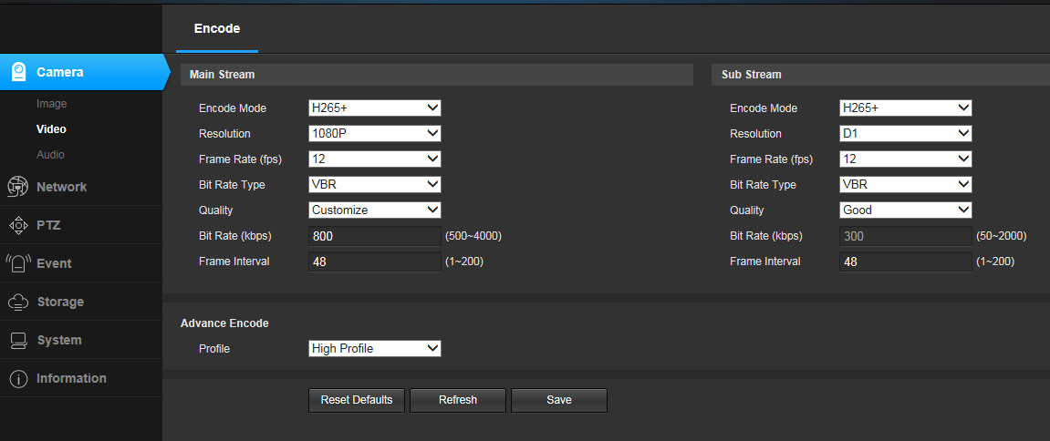
Figure4.4

4.4 Audio encoding settings
The audio encoding settings are shown in Figure 4.5. The main settings are whether audio encoding, encoding, sampling rate, and bit rate are enabled. Only when audio coding is enabled can the device be able to perform sound-related operations such as sound and intercom.

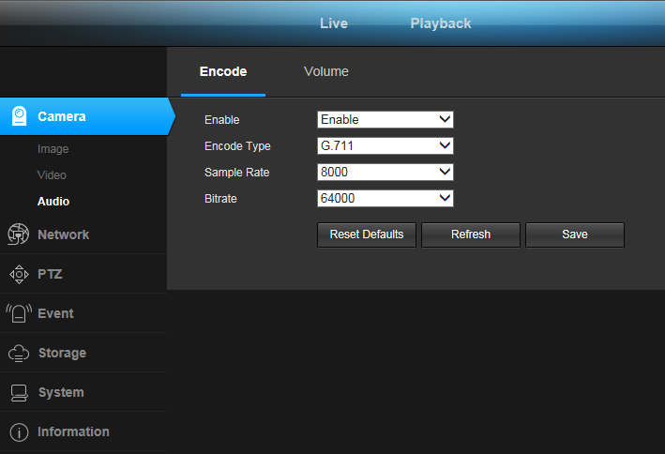
Figure4.5

4.5 Audio capture settings
The audio capture settings are shown in Figure 4.6. You can set the volume level during capture and the volume when playing. The volume can be controlled between 1 and 100. Please set the volume according to your personal situation. After setting the volume, click Save.
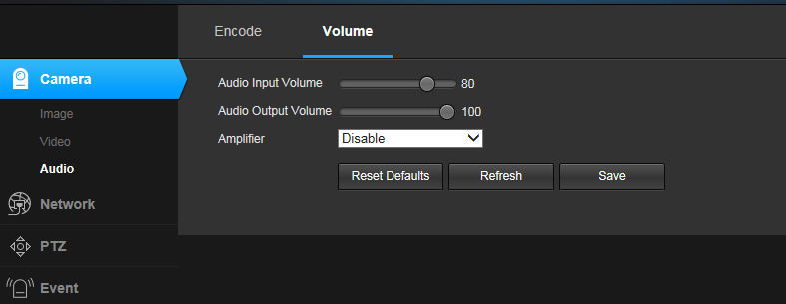
Figure4.6

5、Network

5.1basic configuration
【basic configuration】It is used to set the network parameters of the device. The set network parameters will be displayed in [Network Settings].The setting of each parameter will be explained in detail below.
Dynamic (DHCP) is a LAN network protocol that enables automatic assignment of IP addresses to devices. When there is a DHCP server (usually a router) in the LAN and the DHCP function is enabled, and the device also enables the "DHCP function", an IP address can be automatically obtained according to the DHCP settings of the DHCP server.
The IP address is the address used when accessing the device. You can use the matching AjDevTools search tool to search and modify the IP address of the device. Make sure that the IP address of the computer and the IP address of the device are on the same network segment, and there is no IP conflict between the IP addresses in the LAN, so that the device can be accessed correctly. After the IP address is modified and saved, the system will restart, and then the changed IP address will be used to access the device. An illegal IP address could not be saved and an error was indicated.
The subnet mask is combined with the IP address to divide the network address and host address, usually 255.255.255.0. The correct subnet mask can be saved, the illegal illegal subnet mask cannot be saved, and an error is indicated.
A gateway is a level between two networks (between the internal network and the public network, or between different network segments of the internal network). A general gateway is a router. Set the gateway address and fill in the IP address of the router. When setting up the gateway, the IP address and gateway address must be on the same network segment.
The DNS server address is the host address where the domain name service program is running. The DNS server address is provided by the local network operator. When you do not know the DNS, you can use the Internet to query. When the DNS server address is incorrectly filled, the device cannot connect to the public network, but it does not affect the LAN.
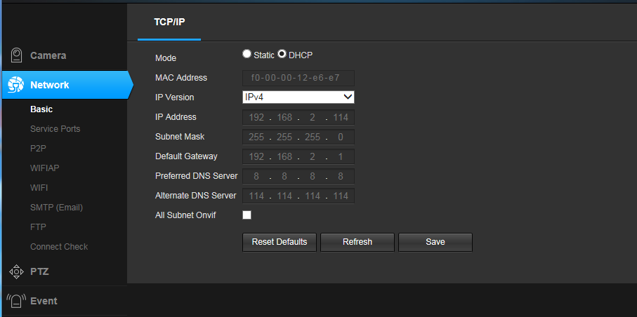
Figure5.1

5.2 P2P Setting
The P2P setting is used to support the external access of the mobile client. After the function is turned on, if the device is connected to the Internet, you can log in to the device from anywhere. This greatly facilitates the user's management and use of the device, no longer limited by time and place. The function is turned off by default as shown below.
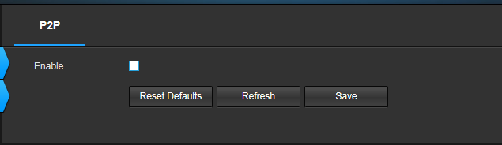
Figure5.2

5.3 Stream Media
The streaming media settings are shown in Figure 3.15.
ONVIF：When enabled, devices that support the onvif protocol, such as platform software or NVR, can search for added devices. After authentication is enabled, a password is required to log in.
Control protocol：This protocol is a transmission protocol that changes the settings of the camera. After shutting down, the device cannot be controlled.
RTSP：When enabled, third-party software (such as VLC) accesses the device and requires a username and password. When disabled, the device can be accessed directly without authentication.
HIK：When enabled, devices that support the HIK protocol, such as platform software or NVR, can search for added devices. After authentication is enabled, a password is required to log in.
DAHUA：When enabled, devices that support the DAHUA protocol, such as platform software or NVR, can search for added devices. After authentication is enabled, a password is required to log in.

Note: The media access port, PTZ control port, and web access port must meet the following conditions when setting: 1. The three cannot be the same; 2. The common port (for example, 3000) cannot be used. 3. When the set port number is not the default port. Both must be greater than 1000 and less than 65536.
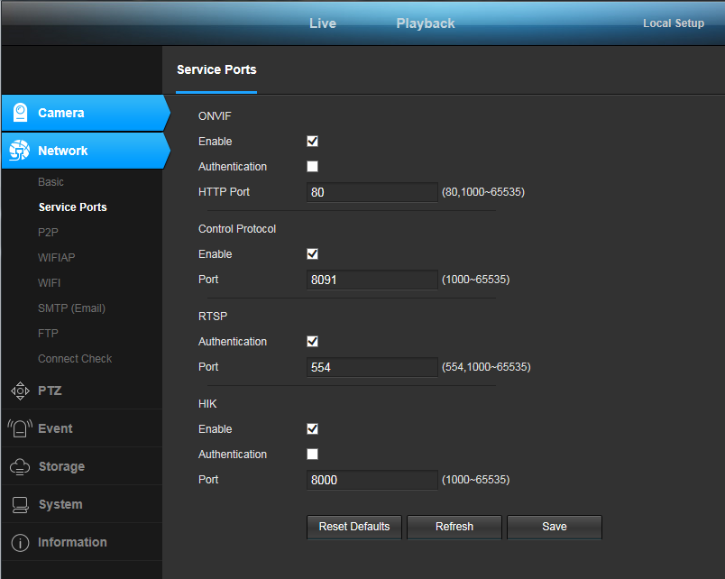
Figure5.3

5.4 SMTP
Add a good mailbox configuration in the SMTP server, the mailbox will receive an alarm message/screenshot after the alarm is triggered. Under normal circumstances, the default port of the domestic mailbox is: 25 (server address 163: smtp.163.com, QQ: smtp.qq.com Website email address is different)

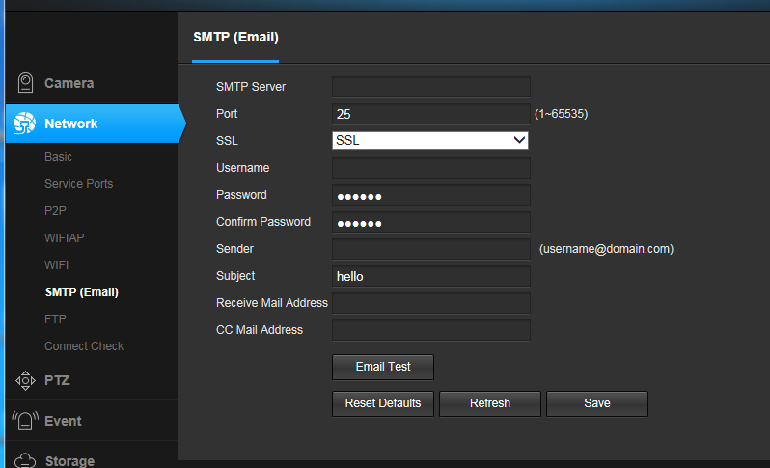
Figure5.4

5.5 GB28181
The platform access settings are shown in Figure 3.16.
The platform access is used to configure whether the device logs in to the access server. When you select Enable, you need to correctly fill in the Access Server Address and Access Server Port. If you are accessing the server for the first time, you need to add the device to the server so that you can see the device in the server.
The server id is 20 digits, and the server ID that needs to be docked is filled in.
Port: The default is 5060. When the SIP service sends a command to the camera, you need to know the port number of the camera GB28181.
SIP service domain: The first 8 digits of the SIP server ID.
SIP server address: IP address of the machine where the SIP service is located
After GB28181 is configured, you need to start the camera GB28181 service.
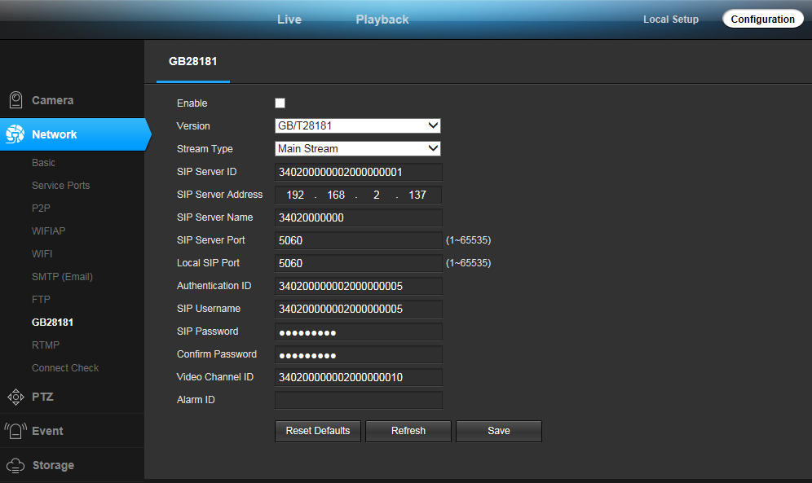
Figure5.5

5.6 RTMP
What is the meaning of the above parameters? For example, the RTMP push stream URL is as follows, and the corresponding parameter can be obtained by character/split.
rtmp://xxx.xxx.xxx/live/4287d69ef405428c?wsSecret=5ba27f7bb727f1b8249d0e1404a398a8&wsTime=5acd71a
1) server address
xxx.xxx.xxx
2) The port number
By default, the default is 1935. If xxx.xxx.xxx is followed by ':number', the number indicates the port number.
3) Application Name
live
4) ID stream
4287d69ef405428c?wsSecret=5ba27f7bb727f1b8249d0e1404a398a8&wsTime=5acd71a

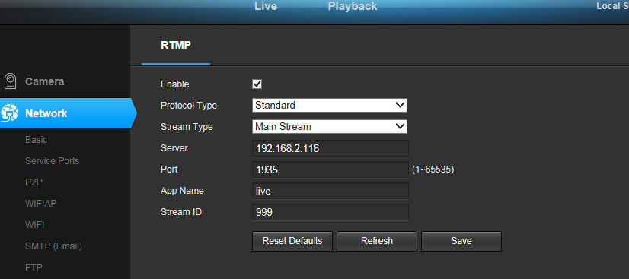
Figure5.6

5.7 Connection check
The above P2P and SMTP functions need to be connected to the network before they can be used. Click the test button to check the network connection.

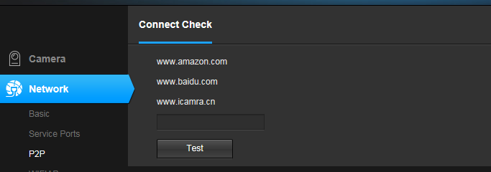
Figure5.7

6、PTZ Setting

6.1 PTZ setting
The basic parameters of the PTZ are shown in Figure 5.1 as follows: PTZ protocol, address code, baud rate, data bit, stop bit, parity, data flow control, boot operation.
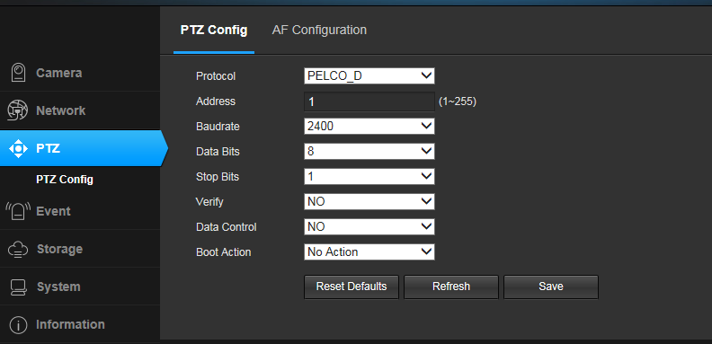
Figure 6.1
PELCO-D data format: 1 start bit, 8 bits of data, 1 stop bit, invalid check, baud rate: 2400B/S. PELCO-P data format: 1 start bit, 8 bits of data, 1 stop bit, invalid check, baud rate: 9600B/S.
The PTZ address code is arbitrarily set using the DIP switch on the dome camera. The address code is 10 digits, and the effective setting range is 1-255. When the address code is set, the address code in the web page must match the address code on the dome camera. PTZ control is effective. When the PTZ protocol, address code, and baud rate settings are consistent with the dome, the PTZ operation can be performed.
The default parameter is a shortcut setting button. The user can use the default parameter key to quickly set the basic parameters. After setting the basic parameters, click Save. The saved system will give a prompt to save successfully.
The basic parameters of the PTZ are related to the selected PTZ. The protocols selected by the PTZs of different manufacturers are not the same. Please refer to the PTZ instruction manual when setting parameters.

7、Alarm Setting

7.1Motion Detection Alarm Setting
The parameters related to the motion detection alarm setting are shown in Figure 7.1:
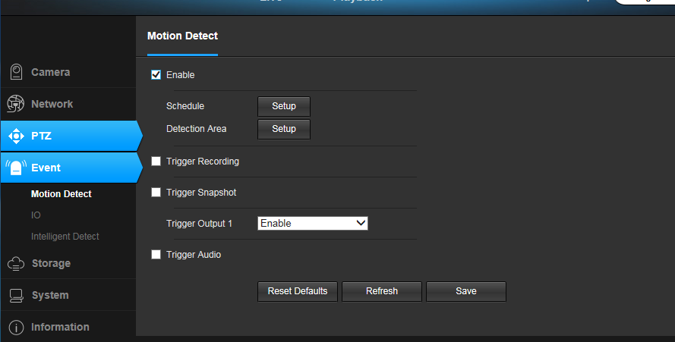
Figure 7.1
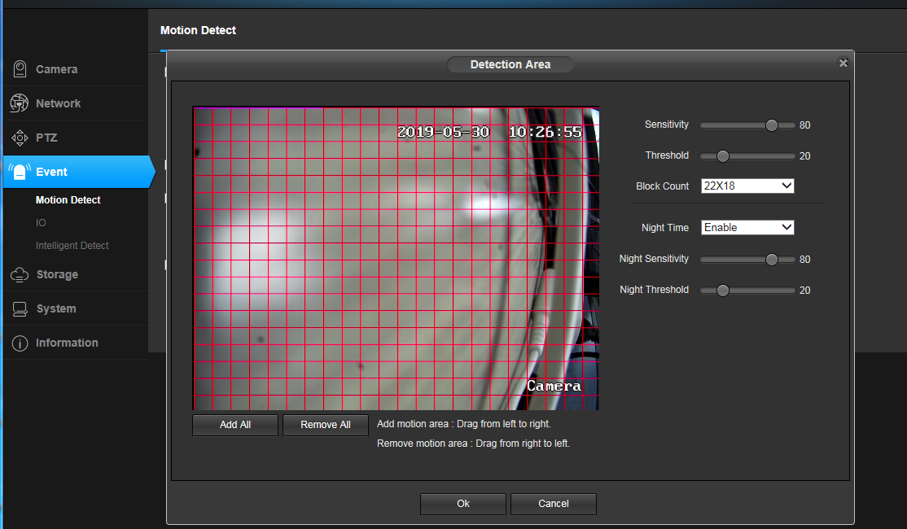
Figure 7.2
Motion detection alarm enable button: When "Enable" is selected, other parameters can be set, otherwise the parameters cannot be modified.
Sensitivity: For the sensitivity of the video range change, the greater the sensitivity value, the easier it is to generate an alarm.
Alarm threshold: Whether the alarm is measured when the video range changes. The smaller the threshold, the easier it is to generate an alarm.
Number of areas: Select how to divide the video range area, the divided video, the motion detection generated by the area contained in the red box will cause an alarm, and the motion detection generated by the area not included in the box will not cause Alarm.
Enable nighttime parameters: When the device is monitoring, it may require different degrees of motion detection for the same degree of day and night, which can be achieved by enabling nighttime parameters. After the nighttime parameter is enabled, the nighttime parameter will be used during the set night time period. If the night time period conflicts with the standard time period, the nighttime parameter will still prevail.
Night start time: The start time at which the nighttime parameter is in effect.
End of night time: The end time of the nighttime parameter effective.
Night sensitivity: Sensitivity during the nighttime parameter period.
Night alarm threshold: The alarm threshold in the night parameter time period.
After setting the relevant parameters of the motion detection, it is also necessary to set the time period during which the motion detection generates an alarm. This function is implemented by the motion detection and defense time period, as shown in the lower part of Figure 6.3.
Use the mouse frame to select the time range for the time. If you need to select the entire day, click the Select All button.
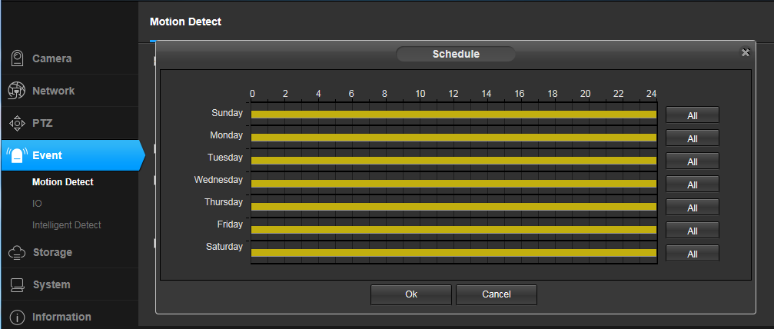
Figure 7.3

The motion detection alarm recording settings are shown in Figure 7.4

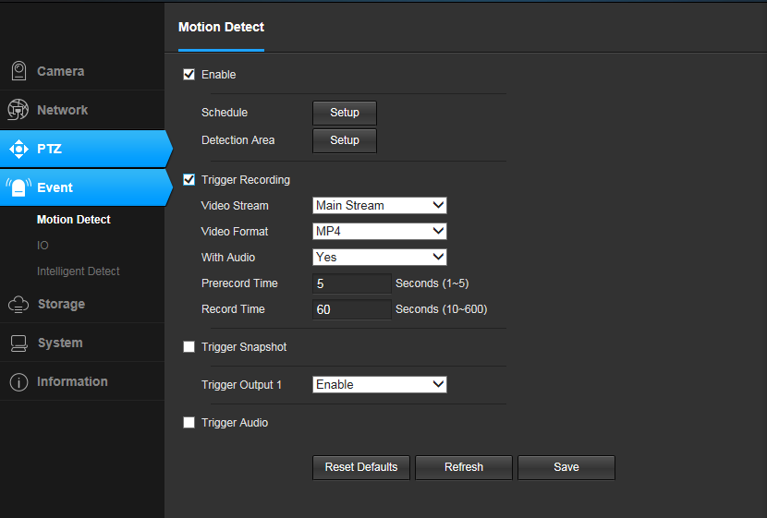
Figure 7.4

When the motion detection alarm recording function is enabled, when the device generates a motion detection alarm, the corresponding video file is generated according to the configuration.
Motion detection alarm recording enable button: When "Enable" is selected, other parameters can be set, otherwise the parameters cannot be modified.
Video source: You can select the video main stream or sub-stream. After selecting the video source, the device will record according to the resolution of the main stream or sub-stream set in [Video Encoding Settings].
Media type: When the device has audio function, the media type can be “Audio and Video” or “Video Only”. When the device does not have audio function, the media type has only one choice, “Video Only”. Select "Video and Audio" and if the device is properly connected to the audio device, the resulting video file will have sound.
Pre-recording duration: The system supports the pre-recording function. When there is no official recording, the data is saved in the temporary buffer. The pre-recorded data is extracted during the official recording. The maximum pre-recording duration of the system is 5 seconds.
Recording duration: The recording time of the video file is 10 to 600 seconds. The length of the recorded video file is the set recording duration.
Upload to FTP: When the FTP-related parameters are properly configured and the upload to FTP function is enabled, the generated video file will be sent to the corresponding location on the server.
Send to Email: When the Email related parameters are configured correctly, the Send to Email function is enabled, and the generated video file will be sent to the configured mailbox by email.
The motion detection alarm capture setting is shown in Figure 7.5
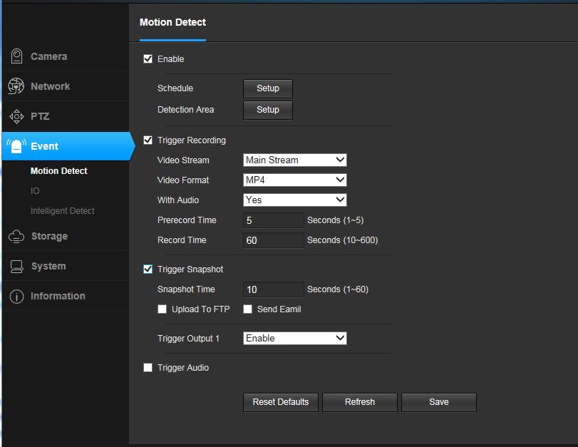
Figure 7.5
When the movement is generated, if the storage space is limited or the video screen that generates the alarm is not required to be recorded, but the reason for generating the alarm needs to be checked, the user can select the motion detection alarm capture function. When the motion detection alarm capture function is enabled, when the device generates a motion detection alarm, it generates a corresponding snapshot image according to the configuration.
Motion detection alarm capture enable button: When "Enable" is selected, other parameters can be set, otherwise the parameters cannot be modified.
The length of the photo: the time to generate an alarm photo, usually 1 second.
Upload to FTP: When the FTP-related parameters are configured correctly, the upload to FTP function is enabled, and the generated snapshot image will be sent to the corresponding location on the server.
Send to Email: When the SMTP/Email related parameters are configured correctly, the Send to Email function is enabled, and the generated snapshot image will be sent to the configured mailbox by email.
Send Frequency: The time it takes to send a snapshot.
Trigger sound When the device is connected to an audio device, turning it on will sound when an alarm is triggered.
You can upload the required audio files as needed (the file size must not exceed 20kb)

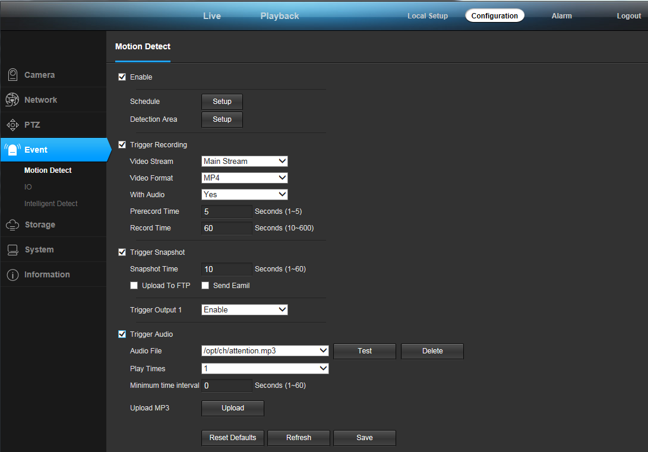
Figure 7.6

8、Storage Settings

8.1 Storage Settings
The storage settings have three parts of settings, storage settings, motion detection alarm recording, motion detection alarm capture, and timing recording, as shown in Figure 8.1
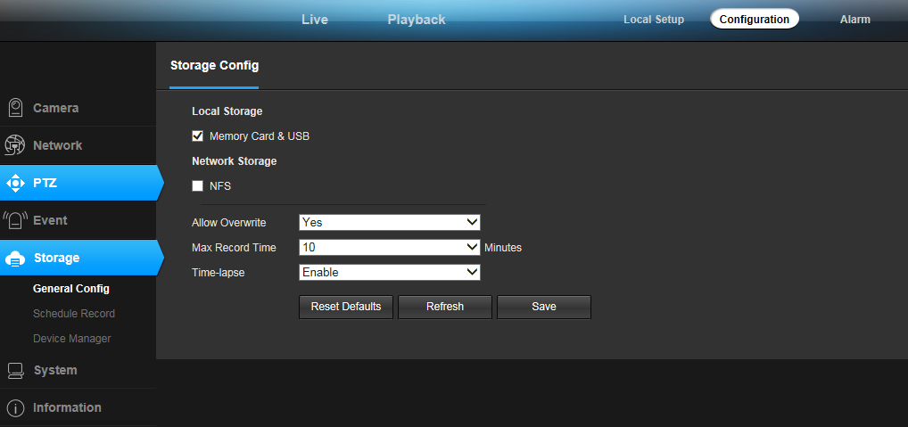
Figure 8.1
The following is a detailed introduction to the configuration of these four parts.
The basic settings of the storage settings are shown in Figure 8.2.

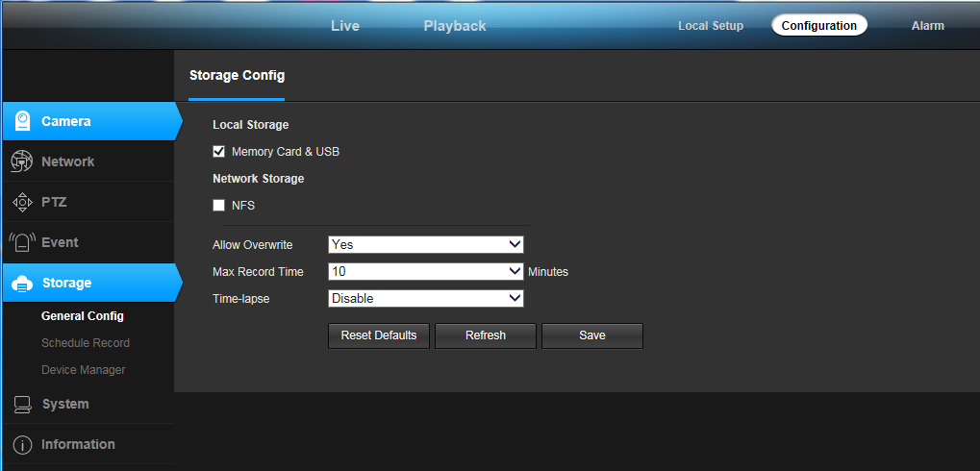
Figure 8.2

Local storage: Local storage (USB/memory card) must be enabled to enable storage of video files and snapshots. Otherwise, storage cannot be implemented.
Storage policy: The storage policy at this location refers to the way the storage device handles when there is insufficient space. Stop recording means that when the storage device is full, the recording will be stopped automatically; overwriting the old record means that when the storage device is full, the system will automatically delete the oldest day's video file, and so on.
Maximum recording duration: refers to the fixed time of each recording file when the device is configured for timed recording. The system provides 5 video file durations to choose from: 2 minutes / 5 minutes / 10 minutes / 20 minutes / 30 minutes. Limiting the length of a single video file can effectively prevent the problem that the playback of a single file is too slow or even impossible to play.
Time-lapse photography: Video compression will be performed after opening, compressing a long video in a short period of time and storing it as a video.

8.2Timed Recording
Set as shown in Figure 8.3
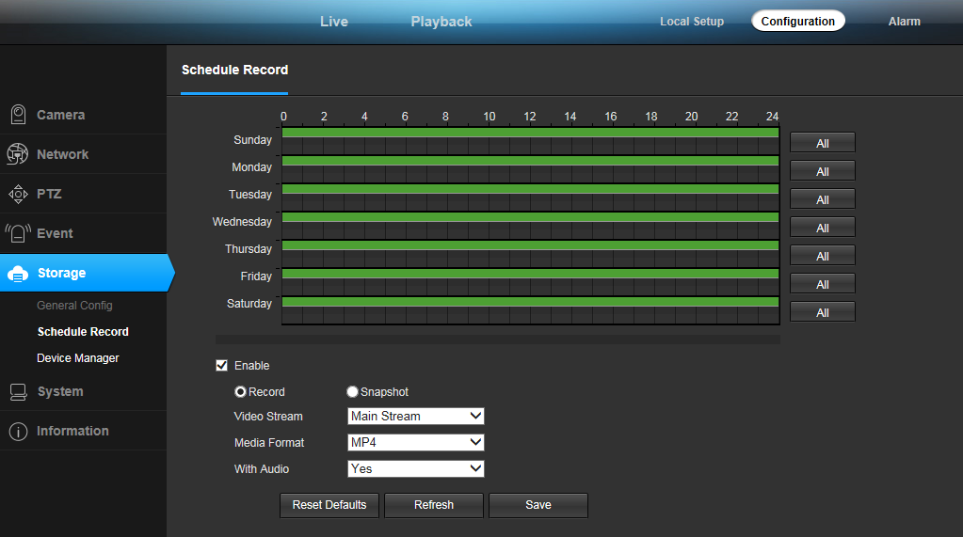
Figure 8.3

Motion detection alarm recording (capture capture) and IO alarm recording (capture capture) are triggered by corresponding alarms, collectively referred to as alarm recording. In addition, the device also supports another form of recording (capture), without conditional triggering, after activation. During the set time, the device will record according to the configuration (take a snapshot), which we call timing recording (capture).
It should be noted that during the same period of time, the timer recording and alarm recording cannot be enabled at the same time.
Timing Record Enable Button: When “Enable” is selected, other parameters can be set, otherwise the parameters cannot be modified.
Video source: You can select the video main stream, sub-stream or picture capture. When the main stream or sub-stream is selected, the video file is obtained. When the picture is captured, the picture is captured.
Video format: According to the selected video source, if it is a video, the video format is AVI; if it is a snapshot, the video format is JPG.
Recording type: According to the selected video source, if it is recording, the recording type is “Video Only” and “Video and Audio”. If it is a snapshot, the recording type is “Snap Picture”.
Capture frequency: This option can be set only when the video source selects “Snap Picture”. Used to set the frequency of the snapshot, that is, how many seconds to capture.
Upload to FTP: This option can be set only when the video source selects “Snap Picture”. When the FTP-related parameters are properly configured and the upload to FTP function is enabled, the generated snapshot image will be sent to the corresponding location on the server.
Send to Email: This option can be set only when the video source selects “Snap Picture”. When the Email related parameter is correctly configured and the Send to Email function is enabled, the generated captured image will be sent to the configured mailbox in the form of an email.
Time period setting: used to set the time period of the timed recording (capture). The time period is determined by the date, start time and end time. After setting the time, click the “Select All” button to directly select 24 time slots. After the timer recording is turned on, the device will record (take a snapshot) according to the settings during the set time period.
Note: 1. The front-end recording and capture function is a front-end independent function, and does not require network transmission. Therefore, as long as the capture or recording function is enabled and properly configured, the device will record or capture according to the configuration when the device is powered on.
2. When the device is not connected to the storage device, no front-end video files can be generated.
3. When the device is not connected to the storage device, the image capture function is enabled, and upload FTP is enabled, and the FTP parameters are correctly configured, and the snapshot image can be generated normally and can be found in the server.

8.3Storage Device Information
Click [Storage Settings Information] to enter the storage device information display interface. This interface details the device status, total capacity, used space, remaining space, and usage percentage of the storage device. As shown in Figure 8.4
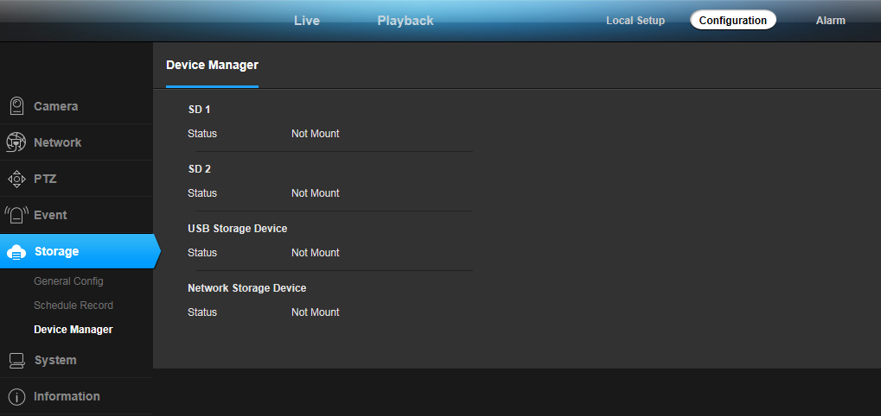
Figure 8.4

8.4Storage Device Management
As shown in Figure 8.5, the management of the storage device is mainly to uninstall and format the storage device from the device. Storage device unmounting is an operation to safely remove a storage device from an IPC. It can prevent damage to the storage device or damage to the storage data caused by the hot-swappable storage device. After selecting the storage device that needs to be uninstalled, click Uninstall. Button, click OK to start unmounting the storage device. After the storage device is safely uninstalled, the storage device will be taken out of service. Click Cancel to interrupt the uninstall operation.
When a device is connected to a storage device but is always unmounted, it may be because the device is not in the same format as the storage device. You can format the storage device first. Select the storage device to be formatted, click Format, and the system will pop up a warning dialog box as shown in Figure 6.7. Click OK, the device starts to format the storage device. After the storage device is formatted, all the data in it will be lost. Therefore, if there is data in the storage device that needs to be saved, it is recommended to transfer it to another place. After the format is successful, the device will mount normally.
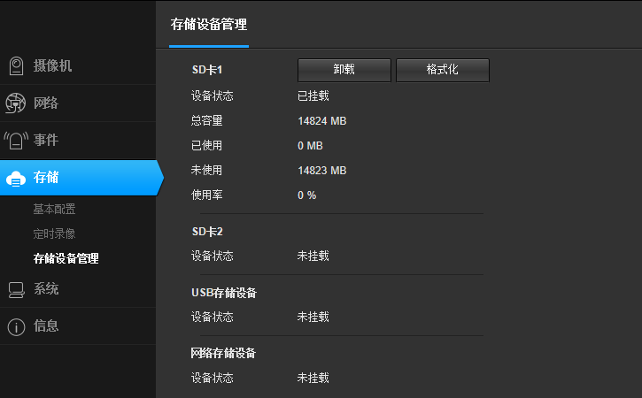
Figure 8.5
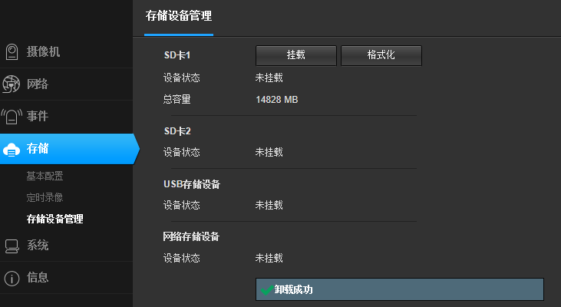
Figure 8.6
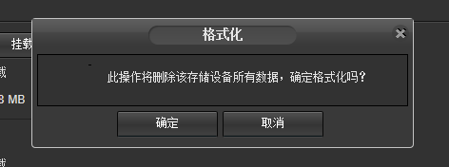
Figure 8.7

9、System Settings

9.1 Account Management
In order to facilitate the management of the device, the super user (default is admin) is allowed to add, delete, modify user information and assign different user rights to different users.
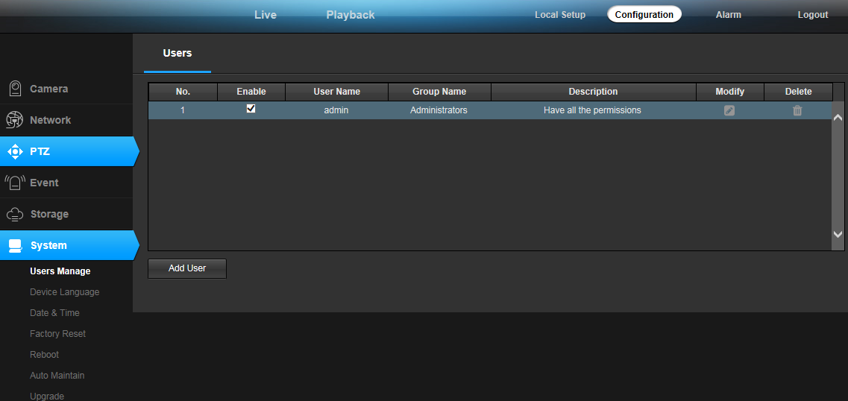
Figure 9.1
Click the option in front of "Add User" to correctly enter the user account, user password, confirmation password of the newly added user, select the user group and enable information of the newly added user, and click the "Save" button to successfully add a user. As shown in Figure 9.2.
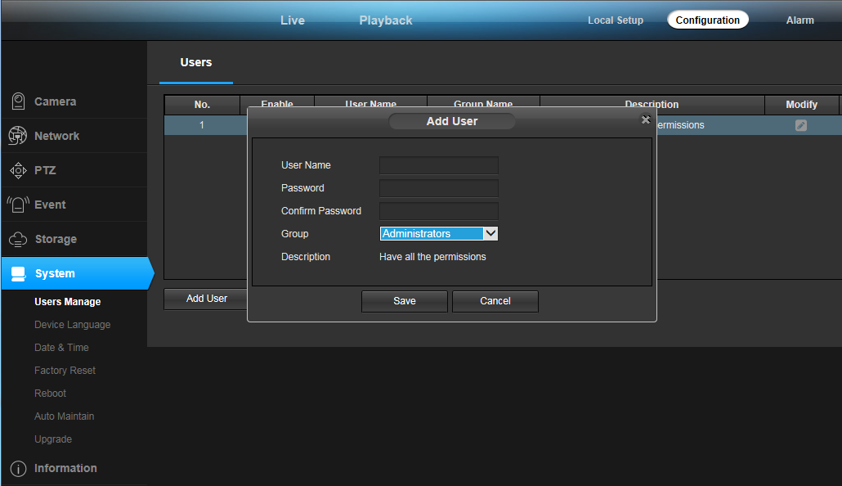
Figure 9.2
When adding a user, the user account and user password cannot be empty, and the user password and the confirmation password must be the same. The user group is used to restrict the user's privilege: the administrator privilege is not restricted, and any operation can be performed on the device; the operator only has the operation permission, and the device information cannot be viewed; the viewer can only view the device information, and cannot modify the device configuration. . Whether to enable the validity of the user is set. When the option is enabled, the added user is activated. After exiting, the device can be logged in with the newly added user name and password. When the option is disabled, the added user name and password cannot be logged in normally. After the information is added correctly, click the "Save" button and the user is added successfully.
When you need to modify a user information, click the button behind the "Modify User" button. When you modify the user, you cannot modify the user name. Other information can be modified. As shown in Figure 9.3.
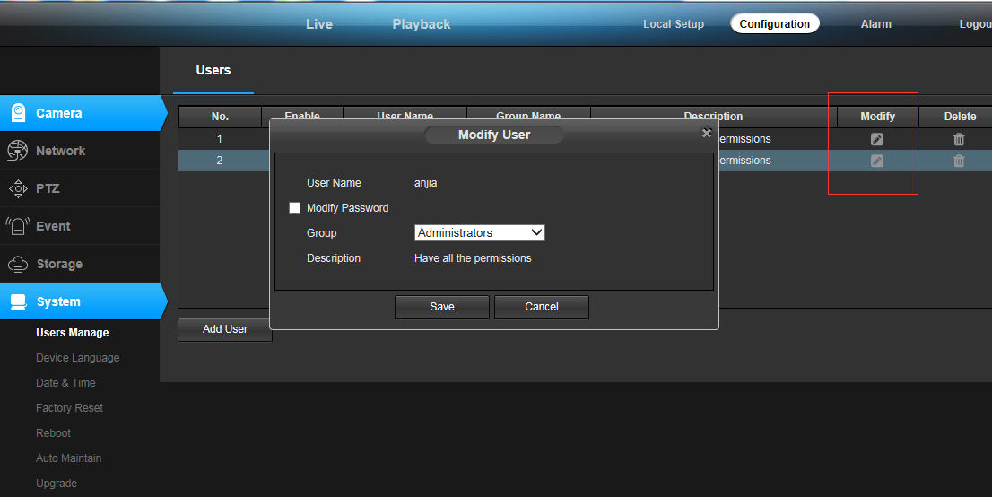
Figure 9.3
Click on the user who needs to be modified in the user list, and the user information will be displayed below. User accounts are displayed in gray and cannot be modified. You can modify the user's password, user group information, and whether it is enabled. After modifying it, click the “Save” button and the user information is successfully modified.
When a user is no longer in use, click the button in front of "Delete User" to delete the user. When deleting a user, it should be noted that the currently logged in user cannot be deleted, that is, the account cannot be deleted. As shown in Figure 9.4.
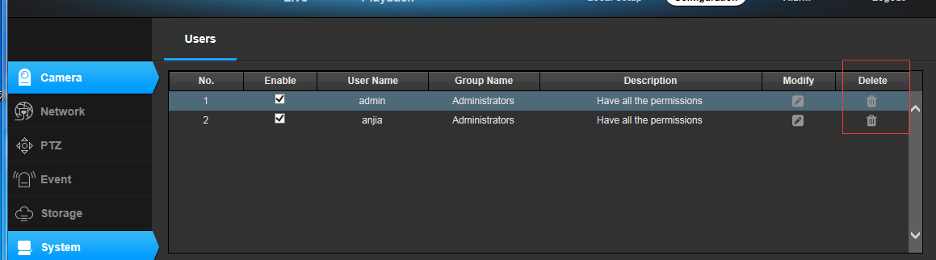
Figure 9.4
Click on the user you want to delete in the user list, and the user information will be displayed below. Click the "Save" button, the user will be deleted, the deleted user will disappear in the user list, and then the user account and user password will not be able to log in to the device.

9.2 Device Language
IPCAMERA now supports three languages: Simplified/Traditional Chinese, English and Czech. After selecting the language, click the “Save” button and the setting is successful. After that, the system will automatically jump to the login interface. When the language version is set and the device is accessed again, the login screen displayed is the language interface set.
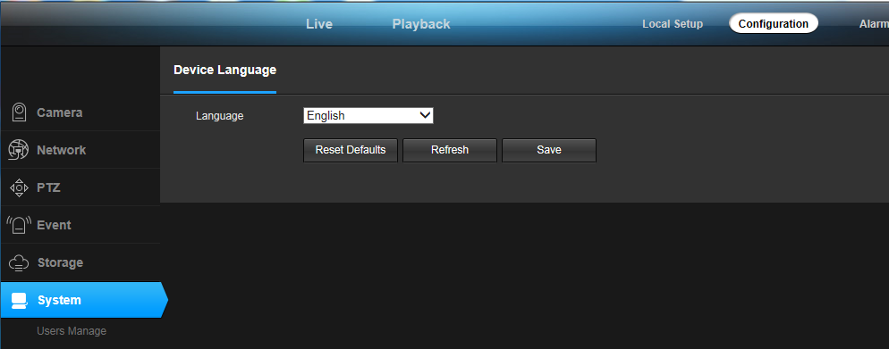
Figure 9.5

9.3 Timer Setting
The system provides three clock setting modes: using NTP service, manual setting, and P2P.
The NTP service is a protocol used to synchronize device time, which allows the device to synchronize its server or clock source, providing highly accurate time correction. After you select Use NTP Service, set the time zone where the device is located, the IP address of the NTP server, and the NTP service port. After the refresh interval is set and saved, the device can synchronize the time. It should be noted that since the device uses network synchronization, implementing this function requires the device to connect to the Internet.
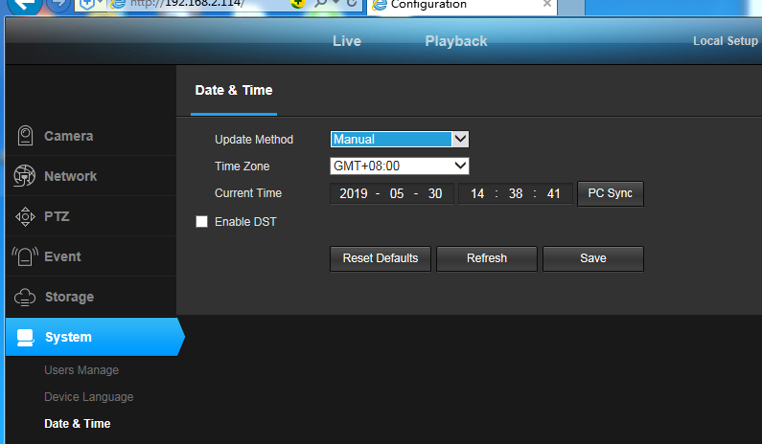
Figure 9.6
Manually setting the time means manually setting the year, month, day, hour, minute, and second. After saving, the time displayed by the device is the time manually entered. In the manual setting time, the function of automatically synchronizing to the current PC time is provided. Check the box in front of “Auto Synchronization” to save the computer time and synchronize the computer time.
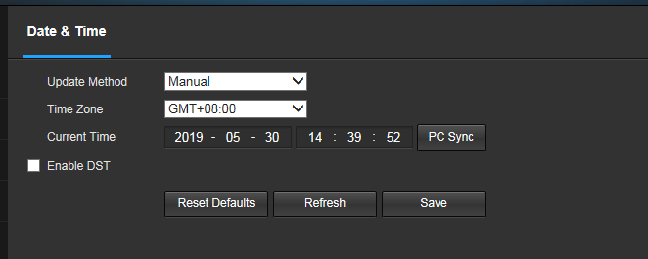
Figure 9.7
The P2P setting time refers to the time when the remote access device is synchronized. If the mobile client is used to access the device, the time of the mobile terminal is synchronized.
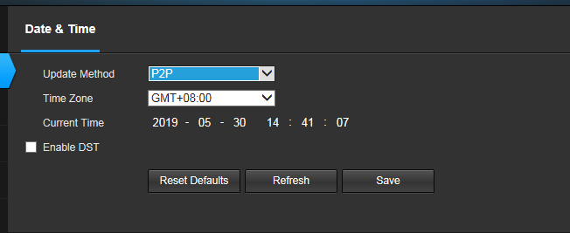
Figure 9.8

9.4 Restore Factory
The system recovery interface is shown in Figure 8.15. After the device is restored to the factory default configuration, the current configuration information such as IP address and video parameters will be restored to the factory default values, and will not be restored. Therefore, you need to be cautious when using this function. consider. After clicking “Restore Factory Default Settings”, a prompt window will pop up to confirm again, as shown in Figure 8.16. The system restart will cause the device to suspend all current processes. After the restart is successful, it will jump to the device login interface.
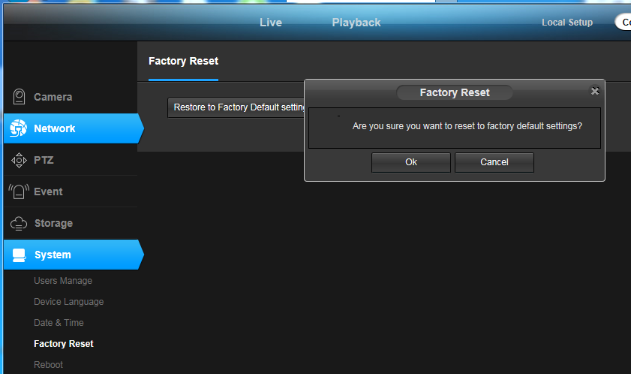
Figure 9.9

9.5Reboot
The system restart will cause the device to suspend all current processes. After the restart is successful, it will jump to the device login interface.
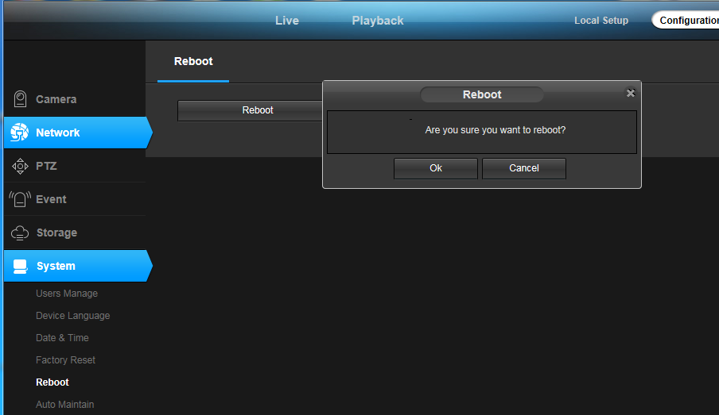
Figure 9.10

9.6 Regular Maintenance
Timed maintenance is used to set the device to restart at the set time. After the date and time are set and saved, the device will automatically restart when the device time runs to the set time. The timed maintenance function allows the device to initialize certain functions by restarting during long-term use, which can extend the life of the device.

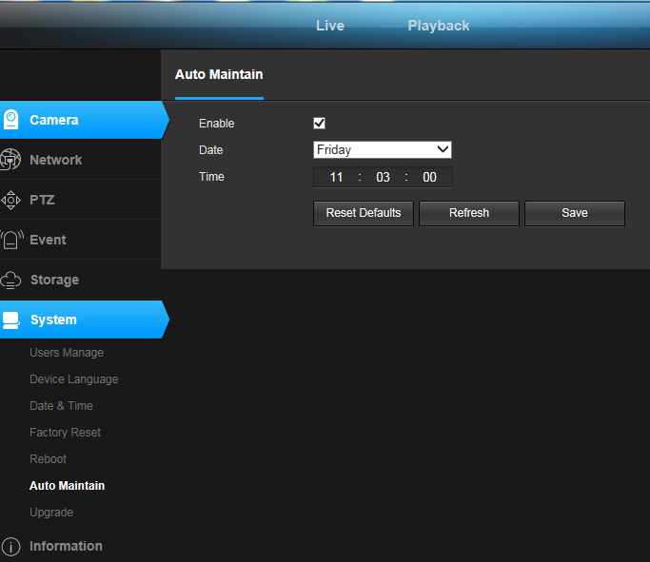
Figure 9.11

9.7Firmware upgrade
The system upgrade interface is shown in Figure 9.12. Click the "Browse" button to jump to the local computer and select the firmware file to be upgraded, as shown in Figure 9.13. After selecting the firmware file, click “Open” and the file path will be automatically filled in the text box after “Firmware File”. Click the "Upgrade" button to start the upgrade. The firmware upgrade is divided into three phases: first, the firmware file upload, then the firmware upgrade. When the firmware is upgraded, the system will perform the countdown; finally, the device restarts, and the system automatically jumps to the login interface after the restart. From the beginning of the upgrade to the completion of the device reboot, the process will last for about two minutes, during which time please do not power off the device.

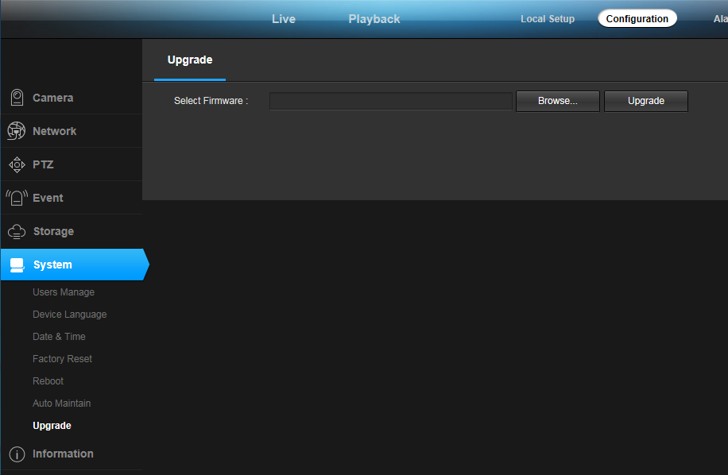
Figure 9.12
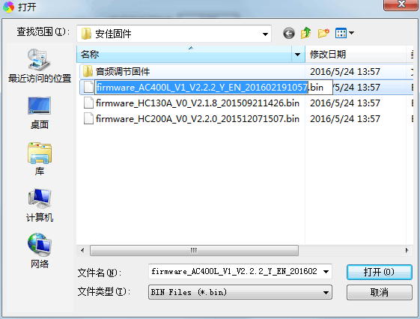
Figure 9.13

10、Version Information
This interface shows the system kernel version, file system version, device serial number, and Web control version of the device in detail, as shown in Figure 9.14.

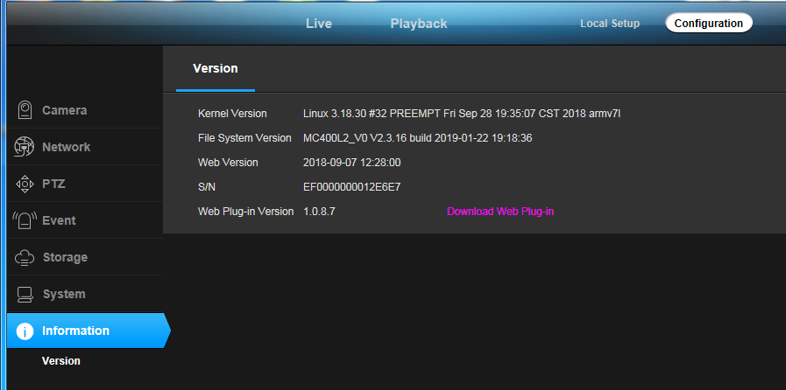
Figure 9.14

11、FAQ

11.1 Cannot access device through browser

There are four possible reasons for this, as follows:
(A) The network is unreachable: The solution is to use the PC to access the network to test whether the network connection can be normal. First, eliminate the cable fault, the network fault caused by the PC virus, until the PC can ping each other (see ping operation). 1.1 Network Status section description).
(B) The IP address is occupied by other devices: the solution is to disconnect the IPCAMERA device from the network, connect it to the PC separately, and reset the IP address according to the appropriate recommended operation (using the IP Search tool).
(C) The IP address is in a different subnet segment: Solution, check IPCAMERA's IP address and subnet mask address and gateway settings.
(D) Unknown cause: The solution is to restore the device to the default state of the factory settings through system settings.

11.2 Yuntai cannot control

The failure to control the gimbal may be caused by the following three reasons:
(A) The PTZ protocol, baud rate, address, and the PTZ protocol, baud rate, and address of the PTZ or camera used are inconsistent.
Solution: Go to the settings page and change the PTZ protocol, baud rate, and address to the configuration of the PTZ you are using.
(B) The signal cable is not connected or the connection is incorrect.
Solution: Reconnect the control line connecting the PTZ to the IPCAMERA device.
- The device does not support the PTZ function because of the model number.

11.3 Normal data cannot pass through the switch

Normal data cannot pass through the switch and may be caused by the following three conditions:
(A) There is a Layer 2 switch. Is the address wrong?
Solution: Before looking for a network failure, be sure to use the ping command to connect to the other party's address in command line mode. Looking at the information returned after ping is a very important part. If no message is returned, the network must be faulty.
(B) Is there a Layer 3 switch, is port and physical address binding?
Solution: If IP and MAC addresses are bound, then you need to make such settings inside the switch, adding a new binding, that is, the camera's IP address and Mac address binding.
- Is the ACL not considered when configuring firewall rules?

Solution: If the switch does not consider the camera when configuring the firewall rules, then it is necessary to allow the camera to communicate on ports 554, 3001, 8000, 8091, 8200, 80 in the default configuration of the camera. Otherwise all packets will be filtered and cannot be reached. If the port of the camera has changed, open the corresponding port of the camera in the switch firewall.

11.4 Error accessing the device through the browser after upgrading

In this case, delete the browser's cache.
The specific steps are as follows: open the browser, select "Tools Menu - Internet Options", click the "Delete Files" button in the second entry (Temporary Internet Files), and tick the "Delete all offline content" option. Then confirm. You can also start on the desktop - run - enter the cmd command - enter enter arp -d to clear the cache, and then log back in to the device.

11.5 After the click, the intercom can't hear the sound.
First determine if the device you are using supports audio, and only full-featured devices have audio intercom. Then perform the following tests:
First, observe whether the icon of the monitoring client toolbar changes to stop after clicking the intercom. If there is no change, the intercom command is not sent, and it takes a few seconds to click again.
Second, confirm that all active audio input and output devices are connected because the device does not have the power supply function for these interfaces.
Finally, confirm that the wheat and headphones on the monitoring side are working properly. You can turn on the recording software that comes with WINDOWS to detect the microphone.

